**Library Management System**

The features that are implemented are search for a book, borrow books if a person has a valid library card, borrowers are fined if the book is not returned within 14 days of checkout. The interface also has a provision to add new borrowers given a valid SSN and phone number.The library management system has been implemented as a web-interface. Front-end was implemented using Angular6, HTML and CSS, and the back-end was implemented using NodeJS wired to MySQL db through Sequelize ORM.

**SEARCHING FOR A BOOK:**

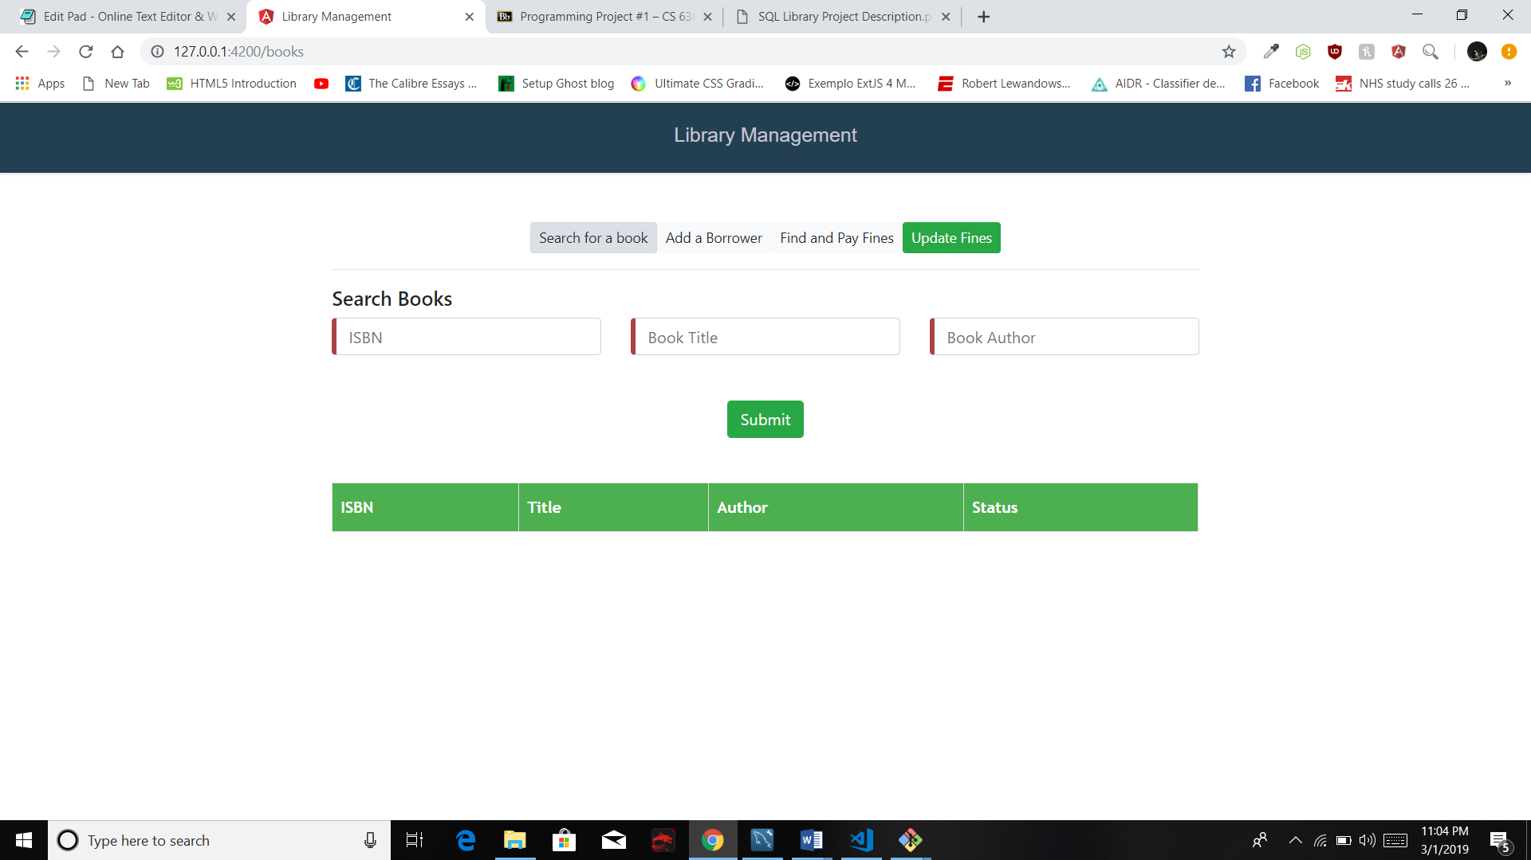

In the space provided the Librarian search based on either ISBN or Book Title or the Book Author. This liberty was taken to help narrow down the search results easily without inundating the user with too many search results to choose from. Substrings are matched for all the three fields.

For example on searching the ISBN substring 0001. We get the following results -

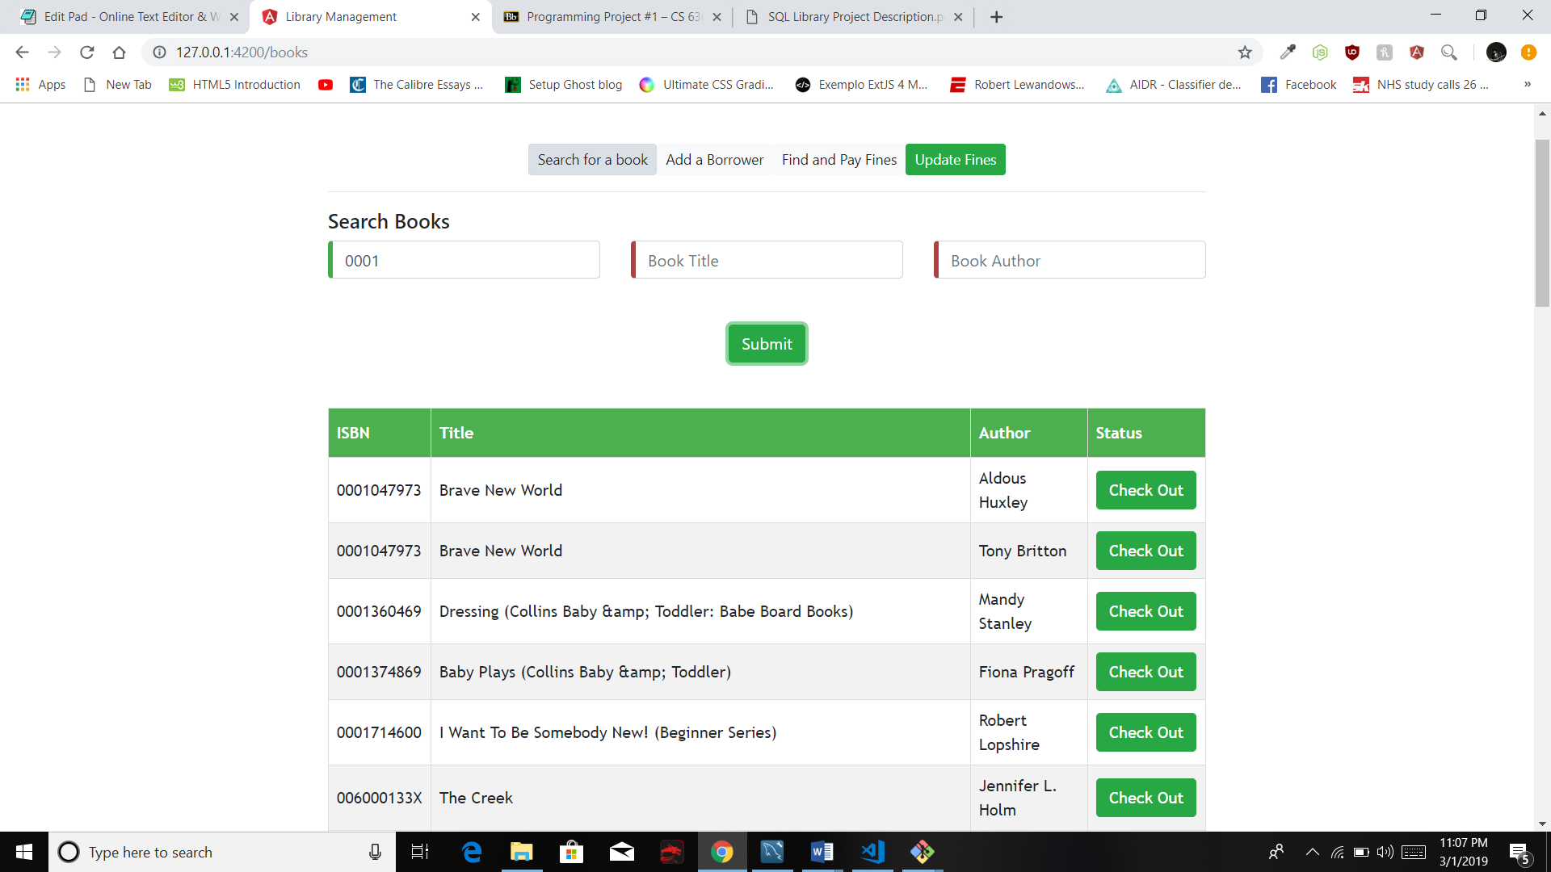

Narrowing it down by the Author Substring Hux results in the following –

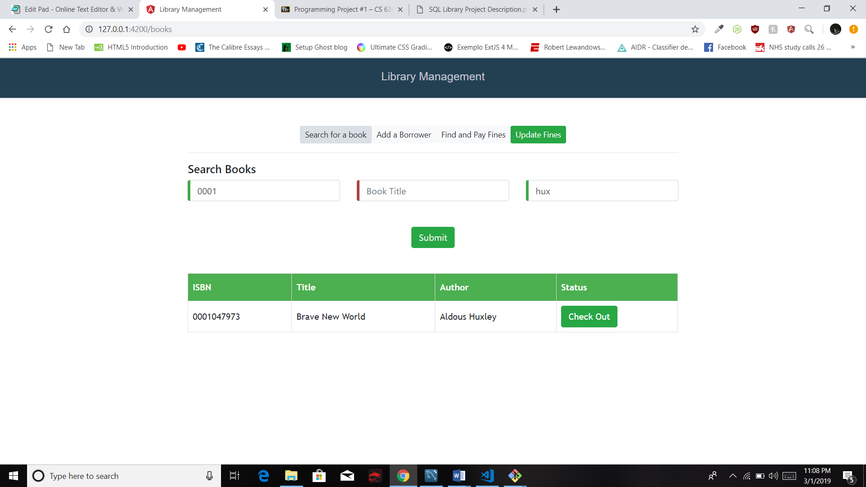

**BORROWIN A BOOK:**

To borrow a book from the library, the borrower should have a valid library card ID. Each borrower can borrow up to three books without returning. A book can be borrowed only by one borrower at a point of time since there happens to be only one copy of each book.

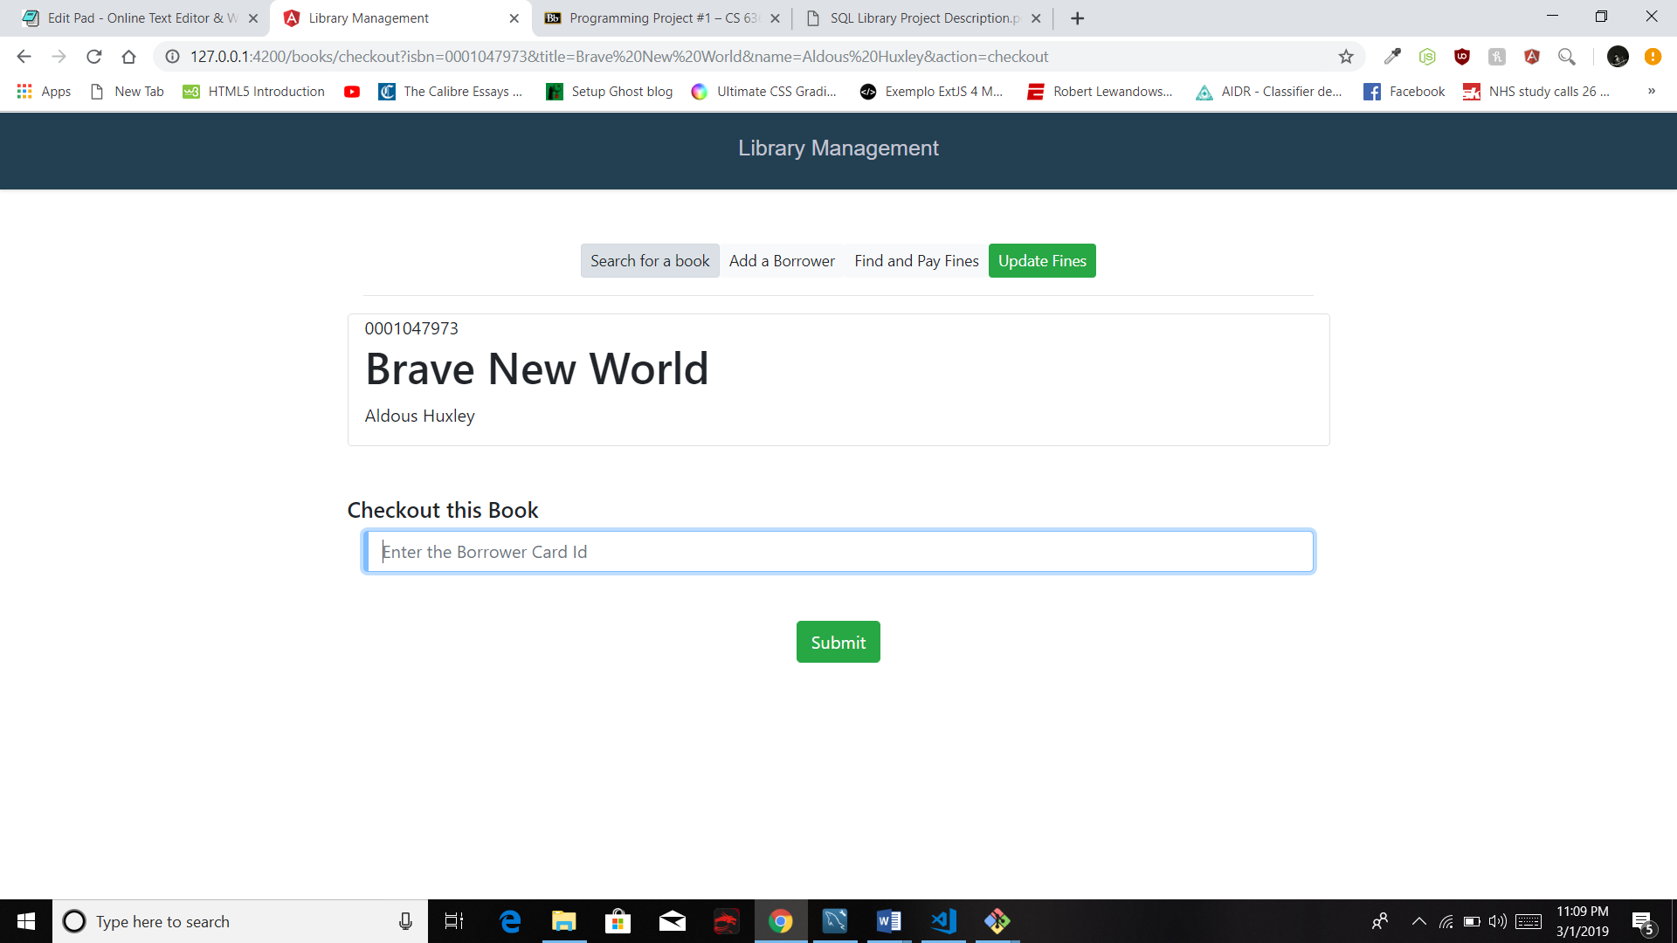

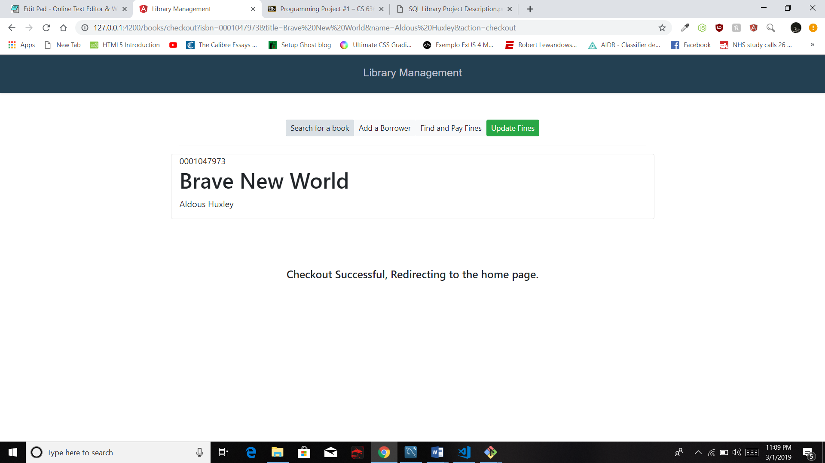

**RETURNING A BOOK:**

To return books, the same search UI is used. Upon searching for the book’s Isbn, a button with check-in functionality is shown instead of the checkout button.

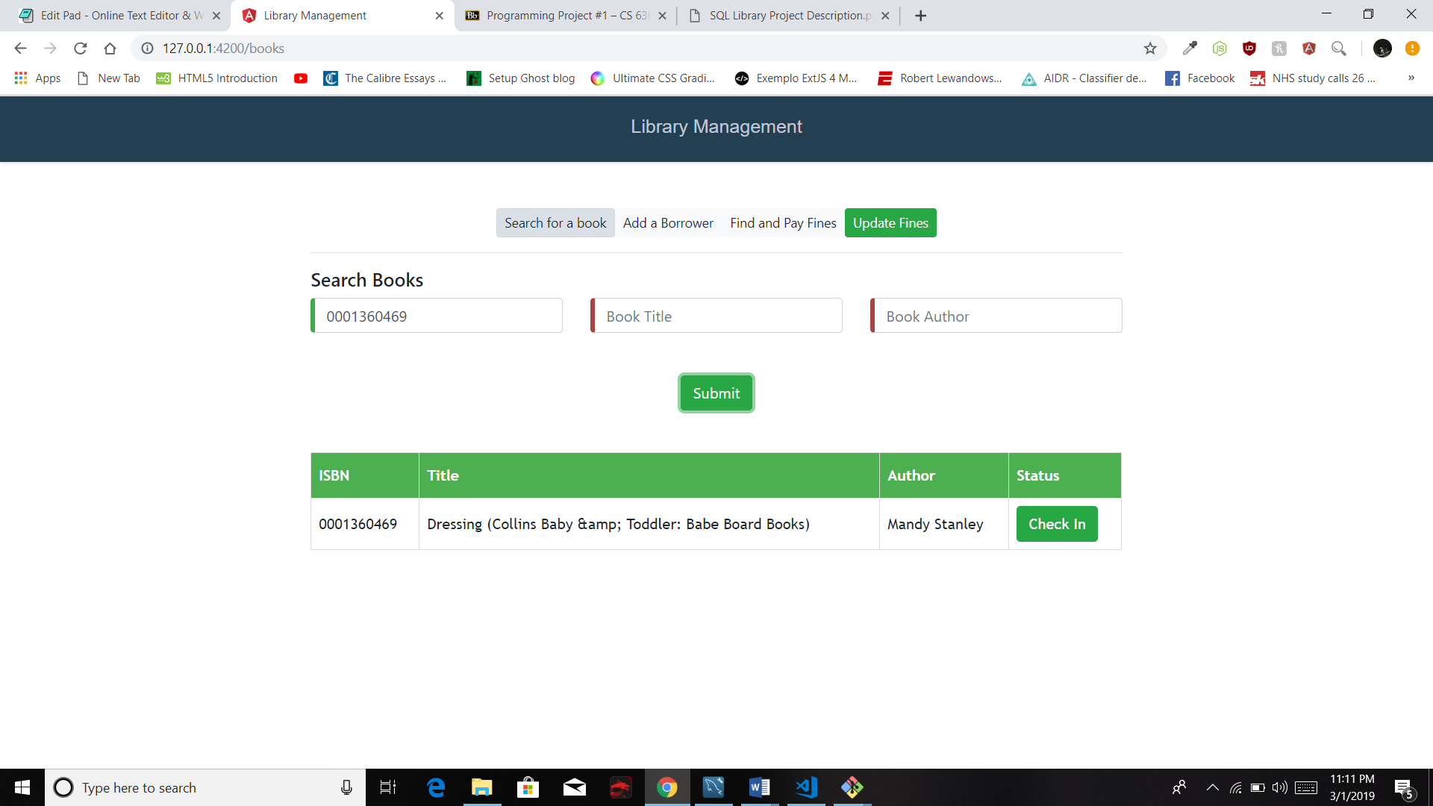

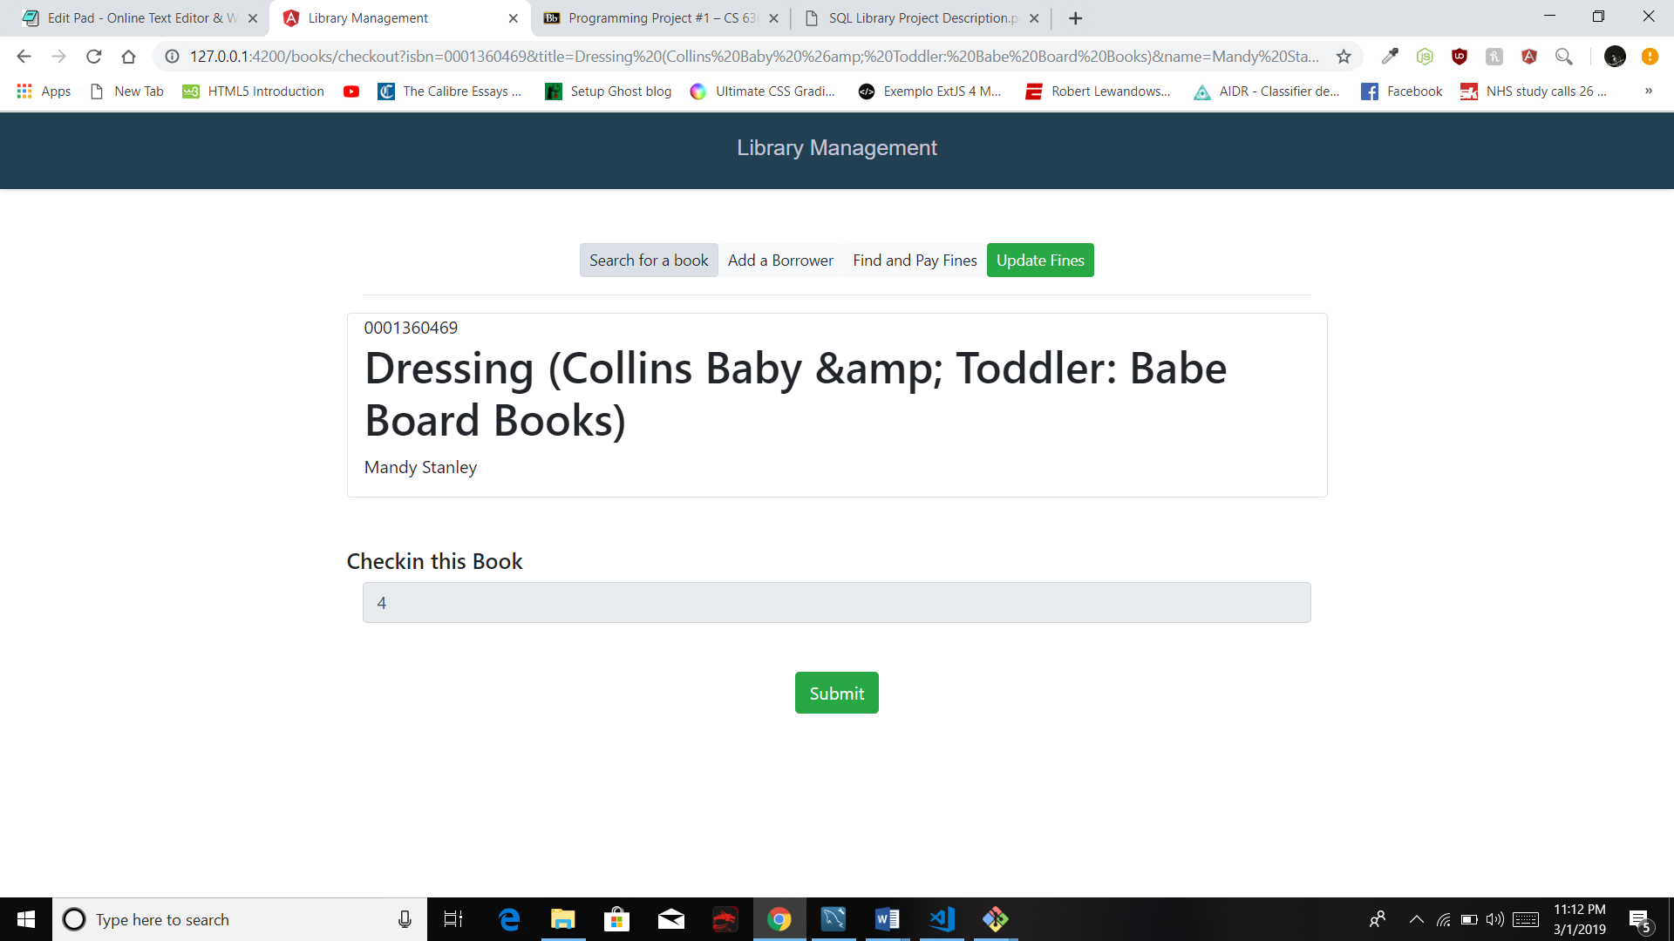

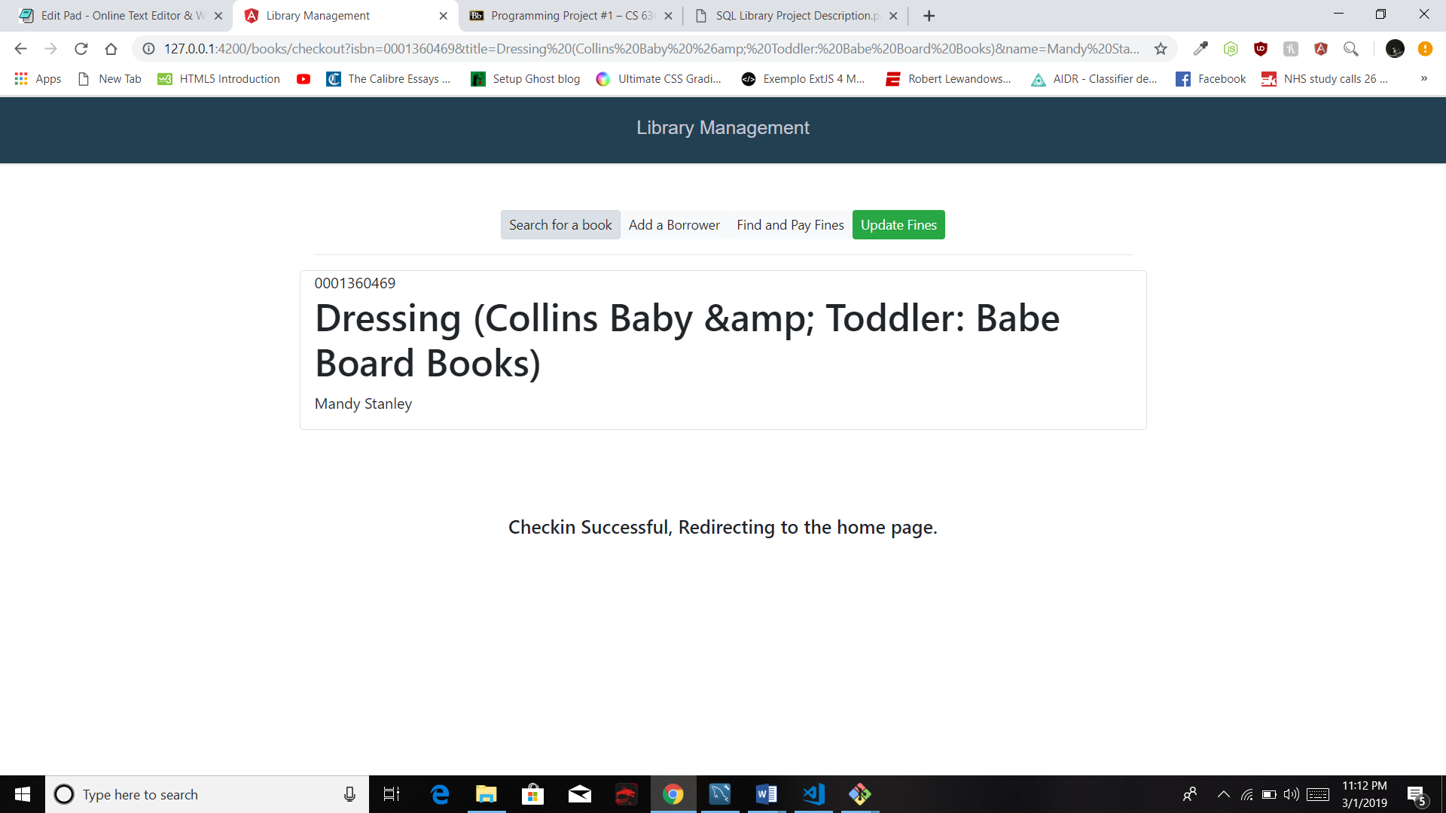

**BORROWER MANAGEMENT:**

Users can add new borrowers to the system by entering the details such as SSN, name of the borrower, address and phone number. Each borrower is required to have a unique SSN.

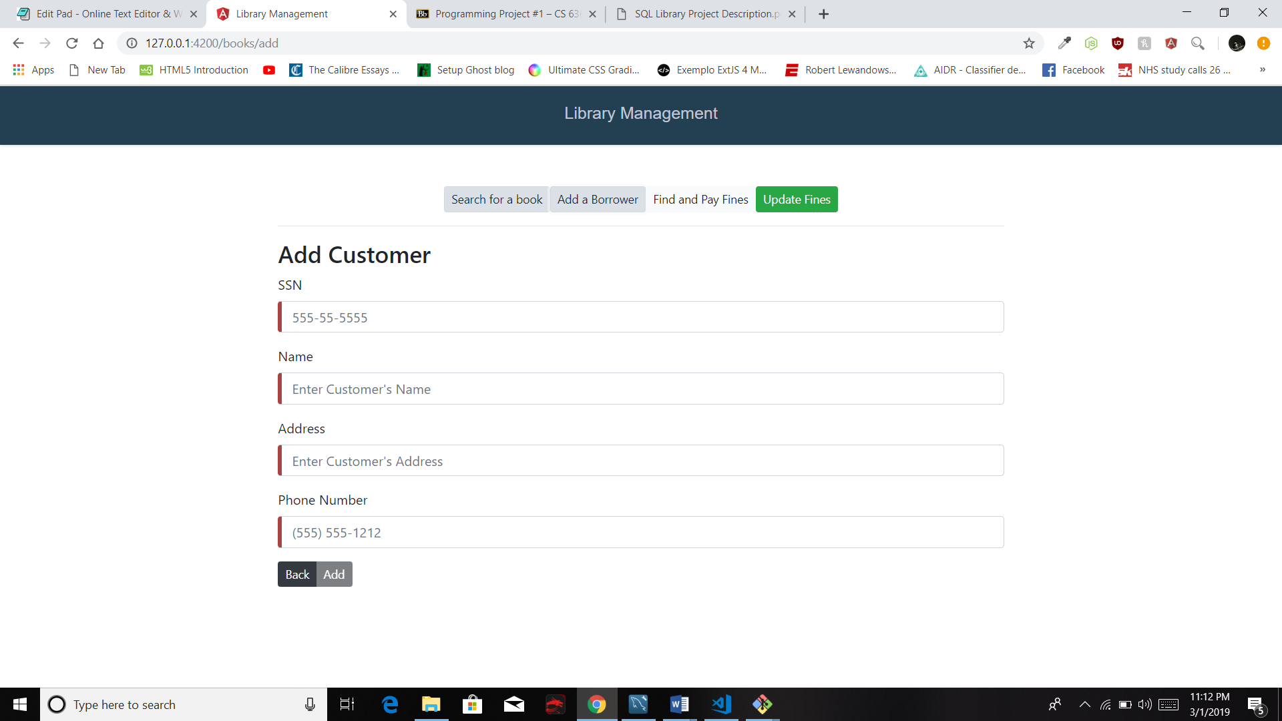

**FINES:**

Fines are calculated when a borrower returns a book and when the fines table is updated manually using the Update Fines button. Fines are calculated as number of days multiplied by the difference of due_date and current date or difference of due_date and the date_in of that particular book.